Initial Project Proposal

Year: 2023 Semester: Spring Project Name: MOUSE (Mobile Observation Unit for Surveillance Equipment); note: our initial project name as GONK

Creation Date: October 1, 2023 Last Modified: October 15, 2023

Team Members (#1 is Team Leader):

Member 1: Andrew Hall Email: hall657@purdue.edu

Member 2: Matthew Ghera Email: mghera@purdue.edu

Member 3: Christopher Miotto Email: cmiotto@purdue.edu

Member 4: Braden Kirkendall Email: bkirkend@purdue.edu

1.0 Description of Problem:

According to the US census bureau, [12] there are 124 million households in the U.S. Of this 124 million households, 51 million of them have some sort of home surveillance system [11]. The problem we are trying to solve is the need for efficient and effective surveillance in various applications, such as security and monitoring. Many of these systems also require a subscription service. The current state of surveillance systems often relies on fixed cameras which have limitations in terms of degrees of vision, flexibility, and cost-effectiveness. We aim to address several critical issues:

* Enhancing security: In an era where security threats are increasingly sophisticated, and not all areas can be easily surveyed by static cameras.
* Cost efficiency: Traditional surveillance systems can be costly to install and maintain, especially in large and remote areas.
* Increased coverage: Static cameras cannot navigate through various terrains to ensure comprehensive coverage.

2.0 Proposed Solution:

In order to solve these problems of enhancing a building’s security, cost efficiency and increased coverage, we will design and construct a small security robot. To solve the problem of enhancing security, the robot will have capability to be controlled remotely or be given a pre-programmed path, both of which can be loaded onto the robot throughout a website interface. The robot will utilize ultrasonic sensors to ensure it doesn’t damage the building, as well as detect any movement. The robot will also enhance coverage by being able to move throughout multiple rooms or the entire building, and be able to provide coverage for the entirety of these rooms. The robot will solve the problem of cost efficiency because it will cost less than installing multiple cameras or devices which current security systems require. The robot will notify the owner of any detected movement through the web interface, so they can investigate it further. Furthermore, the robot will collect its own diagnostic data which will be represented by LEDs on the robot; this diagnostic data will also be visible through the website interface.

3.0 ECE 47700 Course Requirements Satisfaction

The proposed surveillance robot plans to incorporate ultrasonic sensors, a speaker for audio generation, motors for movement, LEDs for diagnostics, and WiFi capabilities for a web-based user interface. Please see Appendix 1 for sketches of our initial proposed design.

3.1 Expected Microcontroller Responsibilities

ECE477 is an embedded systems course which requires the use of a student-programmed microcontroller. We will be using an ESP32 or ESP8266 as our microcontroller. The microcontroller will have the following responsibilities: PWM motor control for drive train, communication through the wifi module for server hosting, transfer of sensor data, and transfer of user input, read and perform logic on ultrasonic sensor data, interact with shift registers to display diagnostic lights, and generate custom sounds outputs. Future functionality may be added to accommodate for the planned features.

3.2 Expected Printed Circuit Responsibilities

ECE477 is an embedded systems course which requires the use of a student-designed and built printed circuit board (PCB). For the proposed project, the PCB is expected to incorporate the microcontroller (ESP32/ESP8266), shift registers and their associated LEDs for diagnostics, power/voltage regulations along with a power supply, speakers and their associated audio control, ultrasonic sensors, and the control system for the motors. Our design will only require a single PCB. Future functionality may be added to accommodate for the planned features.

4.0 Market Analysis:

Our main market is the home security market. The home security market is very large and growing. The market size is currently 60.51 billion USD with an average compound annual growth rate of 8.92% [10]. A new company, Ezviz, has started producing a similar product that acts as a smart, robotic home surveillance camera made $131 million in revenue in 2019 and is growing at a rapid rate [9]. This new, innovative design for home surveillance clearly has a demand, as there are millions of households all that have surveillance systems. There is an expected smaller market on the commercial side, but the MOUSE surveillance system could also be used in this sub-market too.

5.0 Competitive Analysis:

Our overarching design and idea for a surveillance camera has a few similar products on the market. However, the features of the MOUSE security system still differentiate us from the other products on the market. A few other on-the-market surveillance systems have a selection of our features, but there was no system found with all the features implemented together which match our design, audio output, motorized wheels, movement detection, programmable path to follow, web-interface. Because of this, we are hoping to claim a section in this rapidly growing market. The availability of open-source projects with regards to surveillance systems will be helpful and provide us with resources to rapidly ideate certain sections of our project.

5.1 Preliminary Patent Analysis:

While there are not many patents that meet all our features for the MOUSE surveillance system from a technical standpoint, there are a few patents regarding different aspects of a robotic surveillance system that could impact the design. The patents that are being referenced can be found in more detail below.

5.1.1 US Patent Application US7436143B2:

Patent Title: “Miniature surveillance robot”

**Patent Holder:** M Bots Inc

**Patent Filing Date:** April 25, 2006

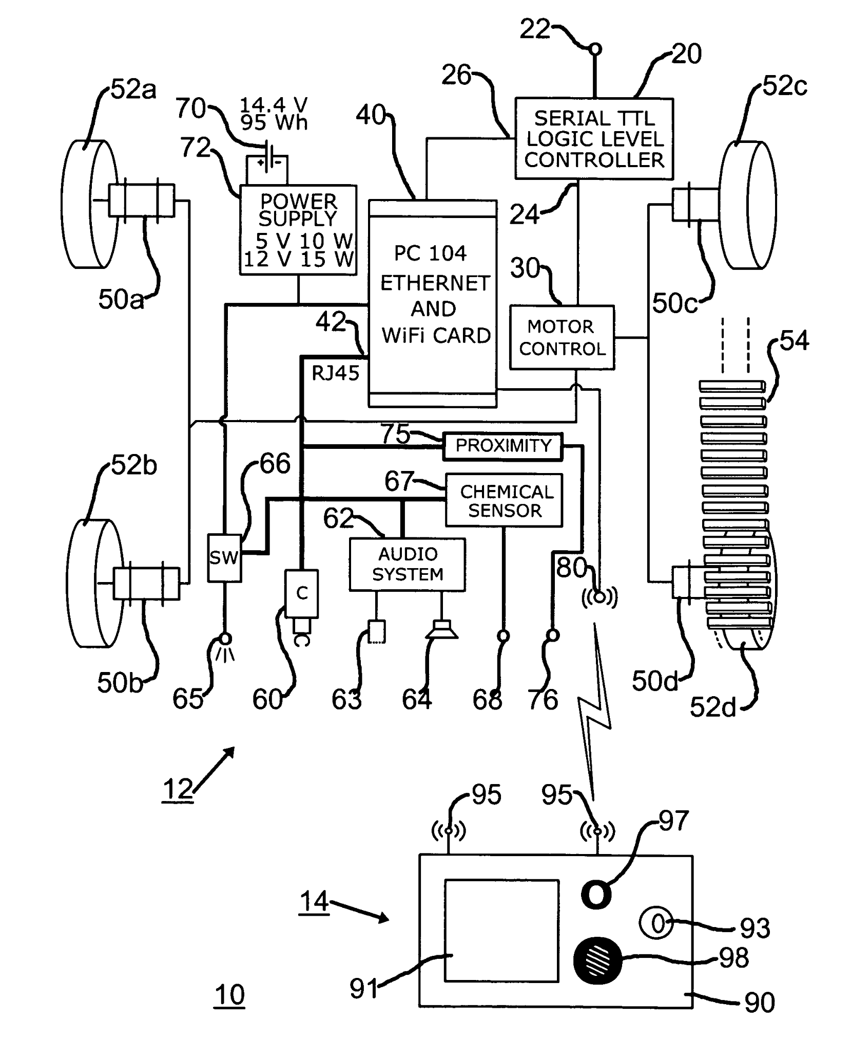

**Figure 1. Miniature Surveillance Robot Design**

This patent [8] details a robotic system with a drive chassis. This drive chassis has a drive motor with a drive element attached to this motor. A motor controller is used to provide signals to the drive motor. In this design, a logic controller provides signals to the motor controller. A network system is included for communicating with the logic controller; at least one peripheral element communicates with the network system as well. The network arrangement is provided to communicate wirelessly with the network system. The preferable peripheral element for this design is a camera configured for the navigation of the robotic system. This camera could also be used for inspecting the underside of a vehicle. There are other versions of this design which have an illumination device, proximity sensing system or chemical sensing system for the peripheral element.

5.1.2 US Patent Application US20220157137A1:

Patent Title: “Facility surveillance systems and methods”

**Patent Holder:** Hexagon Technology Center GmbH

**Patent Filing Date:** December 23, 2021

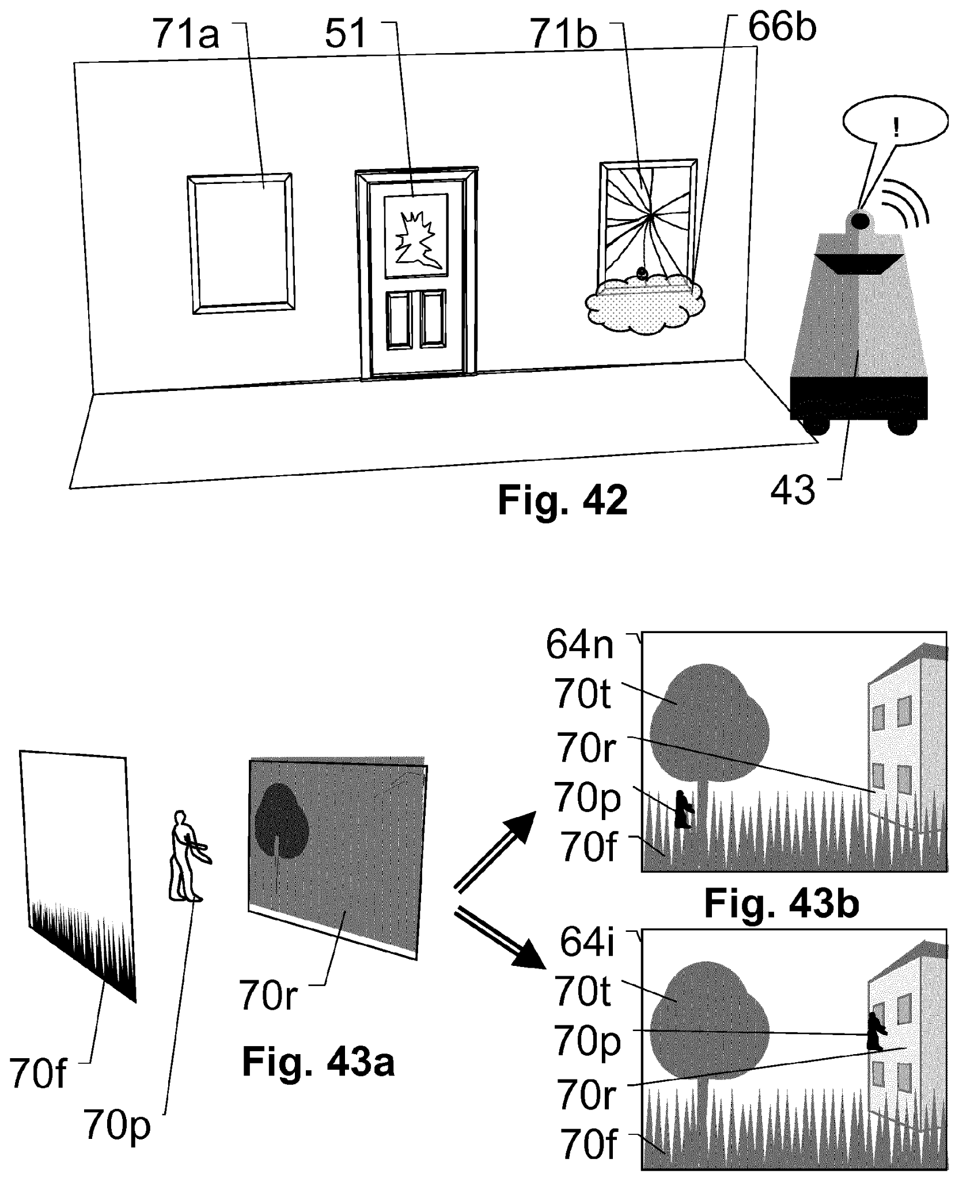

**Figure 2. Facility Surveillance System and Methods**

This patent [7] details systems and methods for surveillance of a facility. The system uses a central computing unit which provides a digital model of the facility. Surveillance sensors in the system are used for generating surveillance data. There are communication means for transmitting data from these surveillance sensors to the central computing unit. The central computing unit uses relationships provided by the facility model to perform a critical-noncritical criticality-classification model for a recorded state pattern. The central computing unit can also perform a normality-anormaily classification model for the recorded state pattern.

5.1.3 Patent #3: US Patent Application US4638445A

Patent Title: Autonomous Mobile Robot

**Patent Holder: Paul J. Mattaboni**

**Patent Filing Date: Jan. 20, 1987**

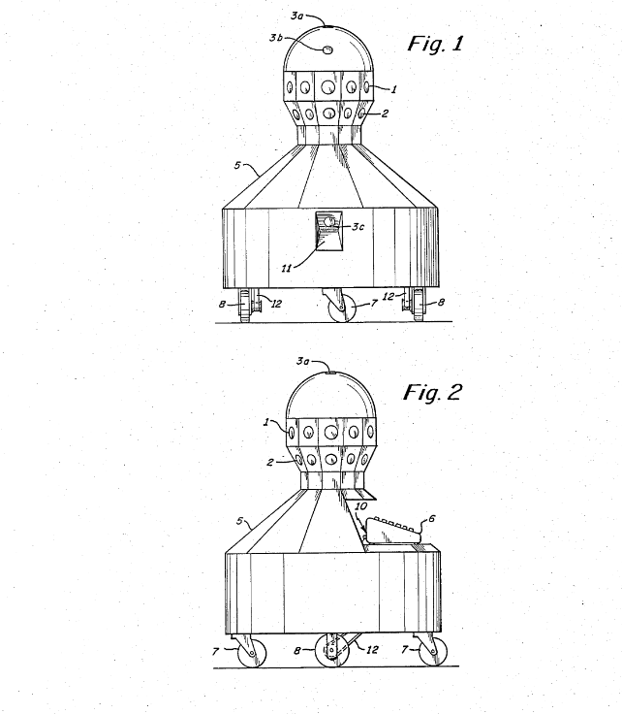

**Figure 3. Autonomous Mobile Robot by Paul J. Mattaboni**

This patent [13] overviews an outline of software behaviors for autonomous vehicle movement based on environmental detection. By using mathematical formulas to determine distance and object placement in 3 dimensional space, the design orients the robot to respond accordingly with its surroundings in a dynamic manner. The hardware aspect of this is an array of transducers for determining axis symmetry and positional data.

5.2 Commercial Product Analysis:

From the commercial products that we found, the surveillance systems similar to what we are targeting are very sparse. Of course, there is the traditional security camera, sold by Ring, which is sold for only $60. This is a very widely used product, and has been perfected and is highly reviewed by its users. However, this is not very close to what we are targeting, as this is not a mobile system. We were able to find two different mobile surveillance systems, but the issue is with how they are purchased. The first, sold by superdroid robotics, is priced at about $50,000 which is not affordable for the average household. The second, sold by smp robotics, doesn’t have a listed price. Both of these sources also do not seem reliable, as they are not a known brand and there is not a lot of content on their trustworthiness online. From this commercial product analysis, there is definitely a hole in the commercial market here as we are targeting a product that is only a few hundred dollars and is mobile.

5.2.1 Ring Indoor Cam, 2nd Gen:

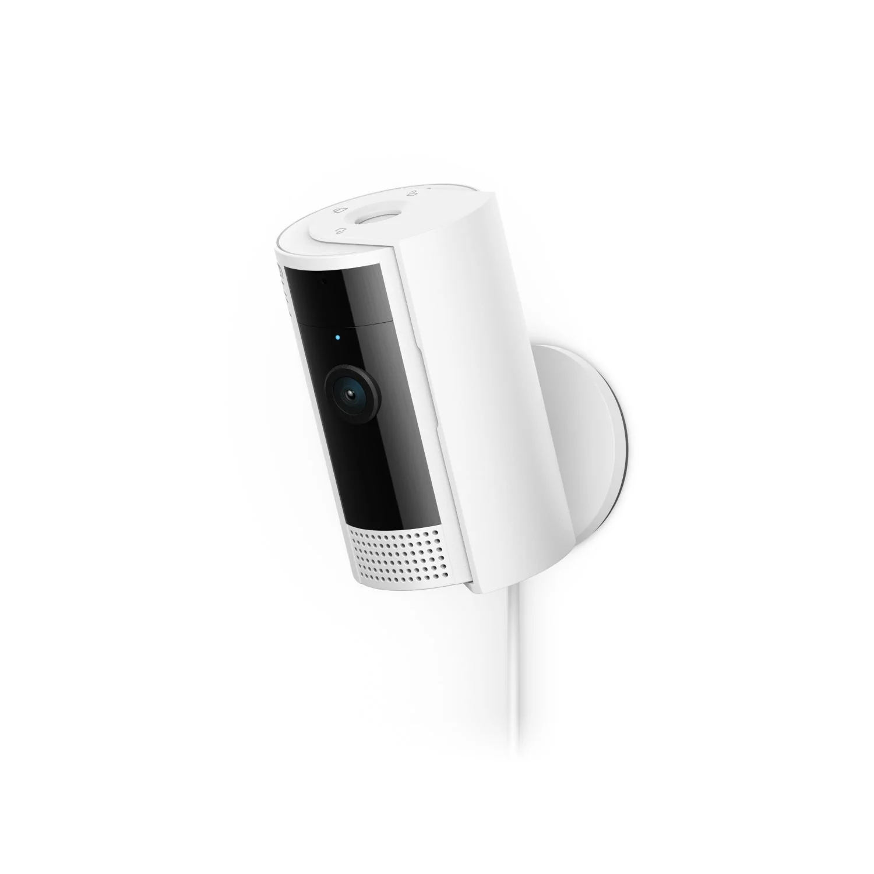

**Figure 4. Ring Indoor Cam, 2nd Gen**

The ‘Indoor Cam, 2nd Gen’ is an indoor security camera made by an US company called Ring [6]. This is the company's second generation of the indoor camera. Some notable features of this camera are the motion alerts and siren. This camera will sense movements and notify the user when motion is detected. The siren can also be activated to scare off intruders. The camera also has 143 degrees diagonal, 115 degrees horizontal, and 59 degrees vertical field of view. The camera will connect to the internet and can be accessed via a mobile application.

5.2.2 SMP Autonomous Mobile Robot:

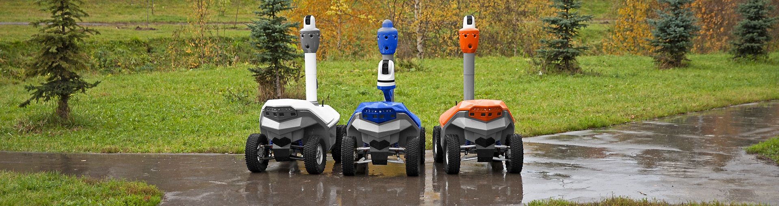

**Figure 5. SMP Autonomous Mobile Robot**

Smp robotics has several autonomous, mobile robots for things like: delivery, inspection, and security [5]. This company has a few issues associated with it as we struggled to find any reviews on their products, so they are not a well-established company. Additionally, they had no price associated with their products, so we have no idea how much they cost. This robot has an autonomous feature and uses a camera to track moving objects. There is very little information on any additional details which of course, is not a good sign that this product is reliable.

5.2.3 SPAR - Autonomous Indoor/Outdoor Security Robot:

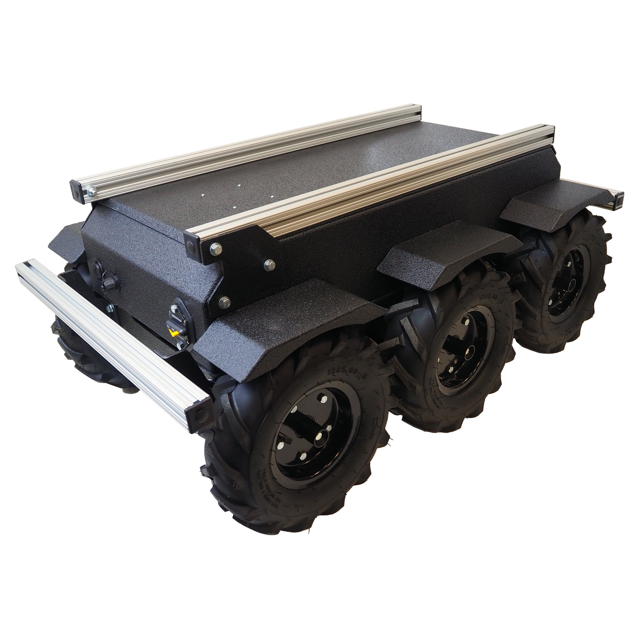

**Figure 6. SPAR - Autonomous Indoor/Outdoor Security Robot**

Superdroid robot has designed a robot called SPAR [4]. SPAR is an autonomous, mobile robot, similar to the SMP robotics. They have an array of both cameras and sensors for object detection. Their HD camera they use has 360 degrees of movement and can see in the night. Additionally, using their array of sensors, the robot can make informed decisions using the input data to decide where to move next. The big issue with this robot is its cost estimated at $50,000. Additionally, we couldn’t find a lot of reviews of this product by consumers.

5.3 Open Source Project Analysis:

There are a reasonable number of open source projects which relate to our proposed surveillance robot. These projects include purely security and surveillance focused projects and security robots. While our project is unique from anything we were able to find, these projects still have useful information for what we plan to design.

5.3.1 ZoneMinder:

This project [3] details a complete surveillance solution allowing the capture, analysis, recording and monitoring of any CCTV or security camera. This project allows the use of any sized system, from a small to very large system. This project is just surveillance software, so it has no robotic component. However, there are still components to this project that aligns with our project. It allows the user to monitor the data from anywhere, which our project will also do. Also, it features that none of the data is on the cloud and you are completely in control of the data. This is similar to what our design will be like, as all the data will be hosted on the robot itself and not stored anywhere else.

5.3.2 Introlab/securbot: Security Robot Prototype:

This project [2] features a framework designed to work with a wide variety of surveillance robots to allow autonomous navigation and threat-reporting. Their design uses lidar readings on the robot’s surroundings presenting the results as a map that can be interacted with by the user. This provides visual feedback on the frontend that can be used to customize robot patrol patterns. Also featured is an event log of all threat-triggered reports Server design was done using easyrtc and integrated with 3 custom PCBs on the robot: a power board, a battery board, and a charging station board. Some advantages of this design are the flexibility to operate with a wide variety of robot chassis, being customizable to better suit the environment they are surveilling. It is also able to visually present the map to the user as it scans its surroundings in real time, providing a better sense of visual feedback to the end user. Another desirable feature is the ability to react to user-selected waypoints that dictate the robot's movement and the events it is notified of.

5.3.3 IoT Surveillance Car:

This project [1] aligns with ours in its ability to move via a controllable interface on a webserver. Although it is not targeted for surveillance, individual components of this project will be good for reference when progressing through our development. This project uses an ESP as the controller for how the user interacts with the robot/car. It also uses ultrasonic sensors for object detection which we may also use. It also has an ESP32cam for vision which may be a useful component for us. It also has a drive train using a servo which we use as a resource, similar to how they are using a 12 volt battery.

6.0 Sources Cited:

[1] R. Vijan, “RV2442/IOT-surveillance-car,” GitHub, <https://github.com/rv2442/Iot-Surveillance-Car> (accessed Oct. 15, 2023).

[2] Cédric Godin, “Introlab/securbot: Security Robot Prototype,” GitHub, <https://github.com/introlab/securbot> (accessed Oct. 15, 2023).

[3] ZoneMinder, <https://zoneminder.com/> (accessed Oct. 15, 2023).

[4] “Spar - Autonomous Indoor/Outdoor Security Robot,” SPAR - Autonomous Indoor/Outdoor Security Robot - TP-300-001, [https://www.superdroidrobots.com/store/usage/surveillance-robots/product=2858?utm_term=&utm_campaign=ET%2B%7C%2BPMax&utm_source=adwords&utm_medium=ppc&hsa_acc=2041907023&hsa_cam=20349989458&hsa_grp=&hsa_ad=&hsa_src=x&hsa_tgt=&hsa_kw=&hsa_mt=&hsa_net=adwords&hsa_ver=3&gclid=CjwKCAjwseSoBhBXEiw A9iZtxht4tb0Nu8-nAlLwjnciNcBMF1gPgJUV6eOE1LeaJClWOBHy82VmehoCC9MQAvD_BwE](https://www.superdroidrobots.com/store/usage/surveillance-robots/product=2858?utm_term=&utm_campaign=ET%2B%7C%2BPMax&utm_source=adwords&utm_medium=ppc&hsa_acc=2041907023&hsa_cam=20349989458&hsa_grp=&hsa_ad=&hsa_src=x&hsa_tgt=&hsa_kw=&hsa_mt=&hsa_net=adwords&hsa_ver=3&gclid=CjwKCAjwseSoBhBXEiw) (accessed Oct. 15, 2023).

[5] Maslov, “Autonomous Unmanned Ground Vehicle Middle Size UGV Outdoor Mobile Robot AMR,” SMP Robotics - Autonomous mobile robot, <https://smprobotics.com/products_autonomous_ugv/> (accessed Oct. 15, 2023).

[6] Ring, “Ring Indoor Cam Plug-in: Mini Indoor Security Camera,” Ring, <https://ring.com/products/mini-indoor-security-camera-plug-in> (accessed Oct. 15, 2023).

[7] B. Metzler et al., “US20220157137A1 - facility surveillance systems and methods,” Google Patents, <https://patents.google.com/patent/US20220157137A1/en?q=%28autonomous%2Bsurveillance%29&oq=autonomous%2Bsurveillance> (accessed Oct. 15, 2023).

[8] S. Lakshmanan, V. J. Varghese, and N. Natarajan, “US7436143B2 - Miniature Surveillance Robot,” Google Patents, <https://patents.google.com/patent/US7436143B2/en?q=%28surveillance%2Brobot%29&oq=surveillance%2Brobot> (accessed Oct. 15, 2023).

[9] intelliStellar, “Smart Home Camera Robots Market Share & Market New Trends Analysis Report by type, by application, by end-use, by region, and segment forecasts, 2,” LinkedIn, <https://www.linkedin.com/pulse/smart-home-camera-robots-market-share-amp-new-trends-analysis/> (accessed Oct. 15, 2023).

[10] Modor Intelligence, “Home Security System Market Share - industry growth,” Home Security System Market Share - Industry Growth, <https://www.mordorintelligence.com/industry-reports/home-security-system-market> (accessed Oct. 15, 2023).

[11] T. Mariotti, “Home Security System Statistics (2023),” RubyHome.com, <https://www.rubyhome.com/blog/home-security-system-stats/#:~:text=Although%20less%20than%20half%20of,million)%20have%20an%20alarm%20system.> (accessed Oct. 15, 2023).

[12] United State Government, “U.S. Census Bureau QuickFacts: United States,” U.S. Census Buerau, <https://www.census.gov/quickfacts/fact/table/US/HSD410221> (accessed Oct. 15, 2023).

[13] P. J. Mattaboni, “US4638445A - Autonomous Mobile Robot,” Google Patents, https://patents.google.com/patent/US4638445A/en (accessed Oct. 15, 2023).

Appendix 1: Concept Sketch

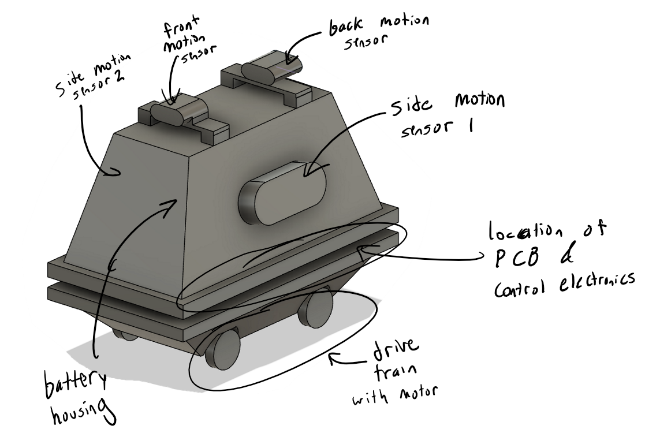

**Figure 7. MOUSE Preliminary CAD Model with Annotations**

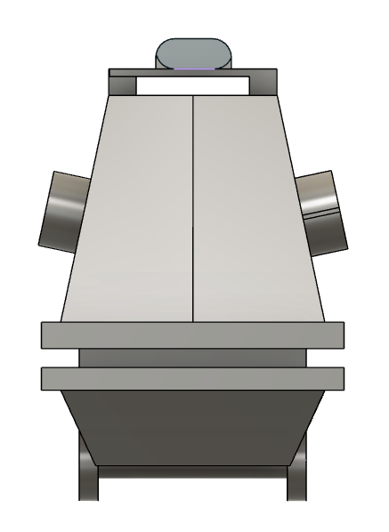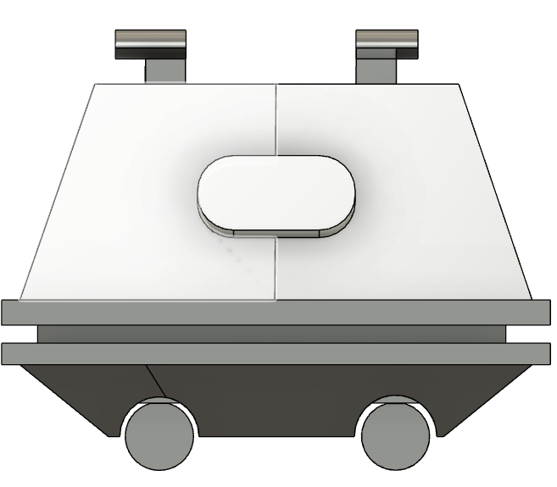

**Figure 8. MOUSE Preliminary CAD Model Front/Side View**

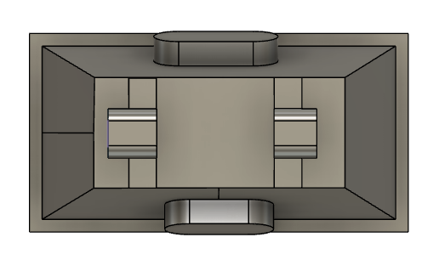

**Figure 9. MOUSE Preliminary CAD Model Top View**